Sri Lanka Institute of Information Technology
Faculty of Computing


IE3121 – Enterprise Architecture
Business Architecture Assessment Report
Client Organization: Travel GO – Smart Travel Agency
Group ID: ISE_WE_0201_55
Year 3, Semester 1 – 2026

Student ID | Name & Epic Ownership
IT24101683 | De Silva H.U.S.T. – Project Manager / EP04 Visa & Payment Management
IT24101865 | Bandara U.G.V.R. – EP01 User, Staff & System Administration
IT24104104 | Dissanayake S.D.D.H. – EP03 Booking & Customer Journey
IT24102390 | Abhimani N.H.A. – EP02 Package, Destination & Hotel Management

Lecturer: Ms. Chathurangika Kahandawaarachchi
Submission Date: ____________________

Contents
1. Executive Summary 6
2. Organization Profile 6
Organization Name 6
Industry Sector 6
Size 6
Products / Services 6
Organizational Structure 6
Current Business Environment 6
Existing Information Systems 6
3. Business Problem Statement 7
4. Stakeholder Analysis 7
4.1 Stakeholder Identification 7
4.2 Stakeholder Matrix 8
4.3 & 4.4 Classification and Impact 8
5. As-Is Business Process Assessment by Epic 8
5.1 EP01 – User, Staff & System Administration 9
5. Process Scope Definition 9
6. Swim lanes 9
7. Process Activities 9
8. Decision Points 10
9. Handovers and Waiting Points 10
10. As-Is UML Activity Diagram – Guidance 11
11
11. Diagram Validation 11
12. Analysis of the Current Process 12
13. Measurable Baseline Indicators (KPIs) 12
14. Process Assessment 12
5.2 EP02 – Package, Destination & Hotel Management 13
5. Process Scope Definition 13
6. Swim lanes 13
7. Process Activities 13
8. Decision Points 14
9. Handovers and Waiting Points 14
10. UML Activity Diagram Guidance 15
11. Diagram Validation 16
12. Analysis of the Current Process 16
13. Measurable Baseline Indicators (KPIs) 17
14. Process Assessment 17
5.3 EP03 – Booking & Customer Journey 18
5. Process Scope Definition 18
6. Swim lanes 18
7. Process Activities 18
8. Decision Points 19
9. Handovers and Waiting Points 19
10. UML Activity Diagram Guidance 20
11. Diagram Validation 21
12. Analysis of the Current Process 21
13. Measurable Baseline Indicators (KPIs) 21
14. Process Assessment 22
5.4 EP04 – Visa & Payment Management 23
5. Process Scope Definition 23
6. Swim lanes 23
7. Process Activities 23
8. Decision Points 24
9. Handovers and Waiting Points 24
From 24
To 24
Information Transferred 24
Possible Issue 24
Customer 24
Visa Officer 24
Visa application + uploaded documents 24
Incomplete documents or poor-quality scans 24
System 24
Customer 24
Missing document alerts / Upfront payment request 24
Technical delivery failure or customer delays response 24
Customer 24
Finance System 24
Upfront fee payment (Visa + Doc charge) 24
Payment gateway timeout, card decline, or customer delay 24
Finance System 24
System 24
Upfront payment status confirmation (Success/Failed) 24
Delay in API status sync between Finance and System 24
Visa Officer 24
System 24
Embassy visa decision (Approved / Rejected) 24
Delay in receiving embassy update or manual entry delay 24
System 24
Finance System 24
Refund request for documentation charge (If Rejected) 24
Refund processing delay in Finance System 24
Customer 24
Finance System 24
Final package balance payment (If Approved) 24
System 24
Customer 24
Final PDF receipt & Booking Confirmation notice 24
10. UML Activity Diagram Guidance 25
11. Diagram Validation 25
12. Analysis of the Current Process 26
13. Measurable Baseline Indicators (KPIs) 26
14. Process Assessment 27
Appendix A – Meeting Notes 27

1. Executive Summary
Travel GO is a company which works in the field of travel and tourism and offers booking of tour packages, help with visa applications, arrangements for flight tickets, and optional hotel accommodation to individuals, families and small tour groups. At the moment the agency makes use of manual, paper-based methods and separate spreadsheets for managing tour bookings, visa applications, customer records and travel packages.
The Business Architecture Assessment looks at the current (As-Is) business processes at TravelGo in four main operational areas which correspond directly to the system epics: (1) User, Staff and System Administration, (2) Catalogue Management (covering Package, Destination and Hotel), (3) Booking and Customer Journey, and (4) Visa and Payment Management.
The main findings indicate that the present procedures involve manual transfers between staff members, repeated data entry, slow cycles when verifying visa documents, inconsistent timelines for sending out booking confirmations, and no real-time visibility regarding booking, payment and visa status for either the staff or the customers. These inefficiencies result in delays in processing, occasional mistakes and lower levels of customer satisfaction, as well as imposing a large administrative workload on a small staff team.
The idea is to substitute the existing manual procedures with an integrated, role-based web platform (Travel GO) which will automate the creation of bookings, the tracking of visas, the simulation of payment processing and the publication of packages and hotels, while at the same time keeping the approval and verification stages that were identified in this assessment. The results serve as the basis for the later Information, Application and Technology Architecture reviews.

2. Organization Profile

Organization Name
Travel GO – Smart Travel Agency

Industry Sector
Travel and tourism services (travel agency and tour operations).

Size
Small-to-medium sized travel agency operating from a head office, with a small team of booking officers, visa processing officers, finance staff, package/destination administrators and management. Serves individual travelers, families and small tour groups.

Products / Services
- Domestic and international tour package bookings
- Visa type guidance, document handling and visa application processing
- Flight ticket information as part of tour packages
- Optional hotel accommodation offered as an add-on during booking
- Customer inquiry handling, reviews and ratings

Organizational Structure
Travel GO is organized around four functional areas that map to the system epics: Administration & User Management, Catalogue (Package/Destination/Hotel) Management, Booking & Customer Management, and Visa & Payment Management, with overall direction provided by senior management/ownership.

Current Business Environment
The agency operates in a competitive market shaped by online travel aggregators (OTAs), rising customer expectations for online self-service and real-time status tracking, and growing demand for combined package + visa + optional-hotel bookings handled through a single channel.

Existing Information Systems
Operations are currently supported mainly by manual paper-based processes, basic spreadsheets, email and phone communication with customers and partners. There is no centralized customer, booking or visa database and no role-based access control across departments.

3. Business Problem Statement
Many travel agencies, such as Travel GO, make use of manual methods or separate, individual systems when they are arranging tour bookings, processing visa applications and putting together travel packages. As a result, there are operational inefficiencies, inaccurate or out-of-date information, and a lack of consistency in customer service. The people who handle bookings and those who deal with visas have to spend a lot of time re-entering data onto spreadsheets and paper forms. Customers do not have the ability to look themselves up and check the status of their bookings or visa applications, and managers have very little insight into the performance of operations throughout the various departments.
In order to enable customers to browse travel packages, book tours, apply for visas and keep track of their requests all via the internet, agency staff are to manage tour bookings, visa applications, customer records and travel packages using role-based access; this is anticipated to lead to greater operational efficiency, improved service quality and higher customer satisfaction.
This assessment covers the customer's processes, booking, visa, payment (simulated) and administrative management, including information regarding flight tickets and optional hotel accommodation; hotel accommodation is not included in the standard package price and is available as an optional extra. The integration of a live payment gateway is not within the scope of this academic project; payment is instead represented as a simulated process.

4. Stakeholder Analysis

4.1 Stakeholder Identification
Stakeholder | Internal / External | Role
Customers / Travelers | External | Browse packages, book tours, apply for visas, make payments, track status
Booking Officers / Travel Consultants | Internal | Manage tour bookings, review requests, confirm or cancel bookings
Visa Processing Officers | Internal | Verify documents, process visa applications, approve or reject
Finance / Payment Officers | Internal | Generate payment requests, confirm payments, issue receipts
Admin / IT Staff | Internal | Manage user accounts, roles, permissions and system security
Package & Destination Administrators | Internal | Create and manage destinations, packages, pricing and hotels
Senior Management / Owners | Internal | Approve high-value exceptions, set strategic direction
Hotel Partners / Airlines | External | Provide hotel/flight information used in packages
Embassies / Visa Authorities | External | Hold final visa-issuance authority (outside the system)

4.2 Stakeholder Matrix
Stakeholder | Interest | Influence | Impact | Engagement | Strategy
Customers | High | Low–Med | High | Keep informed | Feedback via reviews
Booking Officers | High | Medium | High | Involve closely | Train on new workflow
Visa Officers | High | Medium | High | Involve closely | Consult on verification
Finance Officers | Medium | Medium | Medium | Keep informed | Consult on payment
Admin / IT | High | High | High | Manage closely | Involve in access design
Package Admins | High | Medium | High | Involve closely | Consult on catalogue
Senior Mgmt | Medium | High | Medium | Manage closely | Secure sponsorship

4.3 & 4.4 Classification and Impact

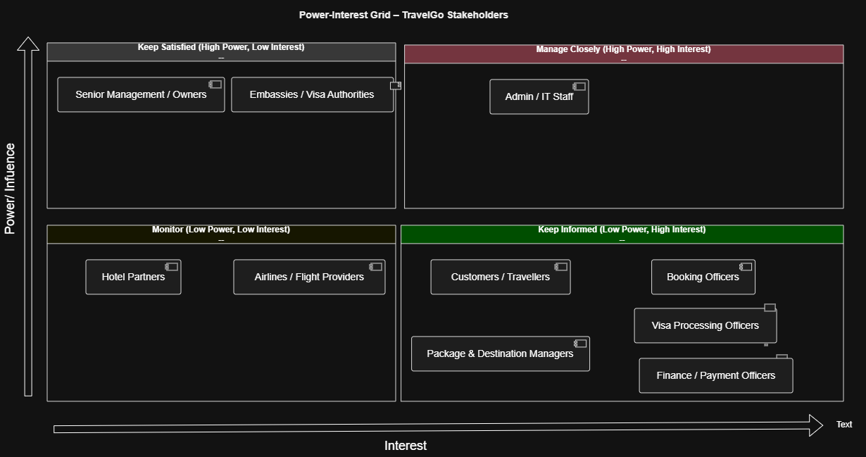
Figure 1 Power–Interest Grid for TravelGo Stakeholders

5. As-Is Business Process Assessment by Epic
Each team member owns one epic and has completed the full process analysis (items 5–14) for that epic.
Epic | Process Analyzed | Responsible Member
EP01 | User Registration & Account Management | Bandara U.G.V.R. (IT24101865)
EP02 | Tour Package, Destination & Hotel Listing | Abhimani N.H.A. (IT24102390)
EP03 | Tour Package Booking Process | Dissanayake S.D.D.H. (IT24104104)
EP04 | Visa Application Processing Process | De Silva H.U.S.T. (IT24101683)

5.1 EP01 – User, Staff & System Administration
Responsible: Bandara U.G.V.R. (IT24101865)

5. Process Scope Definition
Item | Student Response
Triggering Event | A customer or staff member requests an account-related action, or admin needs to update company/system settings.
Start Point | An account request, account change request, or system information update is received by the admin.
End Point | The account or system information is successfully created, updated, activated, deactivated, or the request is rejected.
Main Business Objective | Centralized management of customer and staff accounts, access permissions, company information and basic system settings.
Items Within Scope | Registration, login, profile, customer & staff account management, role & permission assignment, activation/deactivation, company & system settings.
Items Outside Scope | Package, destination, visa, booking, payment and hotel management.

6. Swim lanes
Swimlane | Main Responsibilities
Customer / Staff Member | Submit account requests, provide personal information, request updates, provide corrections, receive status.
Admin / Authorized Staff | Receive & review requests, verify info, check duplicates, create/update accounts, assign roles, activate/deactivate, manage settings.
Management | Review and approve sensitive role/permission requests and important system setting changes.
System (future) | Validate information, check existing records, store data, apply approved changes (currently mostly manual).

7. Process Activities
No. | Activity | Responsible
01 | Submit account request | Customer / Staff
02 | Receive and record account request | Admin
03 | Review submitted information | Admin
04 | Request missing information | Admin
05 | Provide corrected information | Customer / Staff
06 | Validate submitted information | Admin
07 | Check existing records for duplicates | Admin
08 | Determine appropriate role and access level | Admin
09 | Escalate sensitive access request | Admin
10 | Review role/access request | Management
11 | Record user details and create account | Admin
12 | Activate account and assign access | Admin
13 | Notify requester of account status | Admin
14 | Process account update or deactivation | Admin
15 | Update or archive account record | Admin

8. Decision Points
Decision Question | Possible Outcomes
Is the submitted information complete? | [Complete] → Continue; [Incomplete] → Request missing information
Is the submitted information valid? | [Valid] → Continue; [Invalid] → Request correction or reject
Does an existing user record already exist? | [No Duplicate] → Continue; [Duplicate Found] → Update existing or reject
Is the requested access sensitive? | [Standard] → Admin assigns; [Sensitive] → Escalate to Management
Does management approve the access? | [Approved] → Continue; [Rejected] → Reject request
New account or change request? | [New Account] → Creation; [Update/Deactivation] → Modification

9. Handovers and Waiting Points
From | To | Information Transferred | Possible Issue
Customer/Staff | Admin | Account request + personal info | Request delayed or lost
Admin | Customer/Staff | Request for missing information | User responds late
Customer/Staff | Admin | Corrected information | Repeated communication cycles
Admin | Management | Sensitive access request | Manager unavailable
Management | Admin | Approval/rejection decision | Decision not properly recorded
Admin | Customer/Staff | Account status notification | Notification delayed

10. As-Is UML Activity Diagram

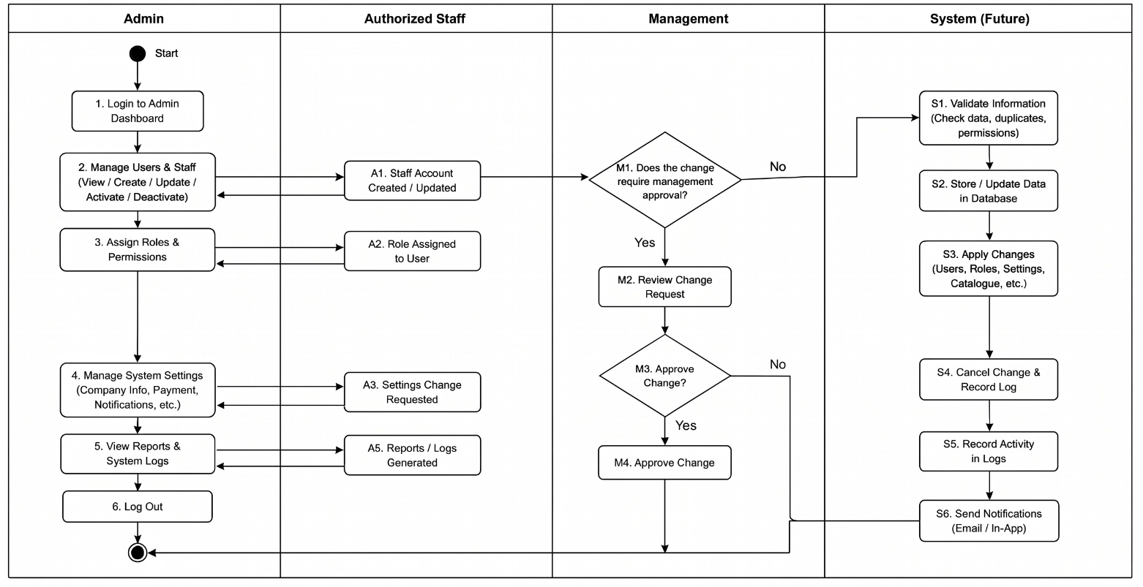
Figure 2: EP01 – User, Staff & System Administration

11. Diagram Validation
Validation Question | Yes | No | Comments
Is the start of the process clear? | ✓ |  | Initial node present
Are all major actors represented as swim lanes? | ✓ |  | Customer/Staff, Admin, Management
Is every activity in the correct swim lane? | ✓
Are activity labels clear and action-oriented? | ✓ |  | Verb–object style
Are decision outcomes shown with guard conditions? | ✓ |  | [Complete], [Approved] etc.
Are rejection paths represented? | ✓
Are rework loops represented? | ✓ |  | Missing-info loop
Are end points clearly shown? | ✓ |  | Two final nodes
Does the diagram represent the AS-IS process accurately? | ✓ |  | Manual process

12. Analysis of the Current Process
No. | Problem Identified | Evidence | Business Impact
1 | Manual fragmented record keeping | Details in spreadsheets, paper or separate files | Data inconsistency, hard to locate info
2 | Manual duplicate checking | Admin must manually search existing records | Duplicate accounts, extra effort
3 | Delays from multiple handovers | Requests move between customers, admin, management | Account creation delayed
4 | No clear access approval records | Approvals via email or verbal | Difficult to audit approvals
5 | Repeated rework for incomplete info | Missing info causes extra communication cycles | Longer processing, user frustration

13. Measurable Baseline Indicators (KPIs)
KPI | How It Could Be Measured
Average account creation time | Time from receiving request to activating the account
% of requests returned for missing information | Requests requiring missing info ÷ total requests × 100
Average account update/deactivation time | Time from receiving update request to completion
Number of duplicate user records | Count of duplicates found in periodic review
Average management approval time | Time from escalation to management decision
% of requests requiring rework | Requests with ≥1 correction cycle ÷ total × 100

14. Process Assessment
The current User, Staff & System Administration process operates mainly through manual procedures, spreadsheets, paper records, email and informal approval methods. When a customer or staff member requires an account, a request is submitted to an administrator who reviews the information, checks for missing details and duplicates, and determines the required role. Sensitive access requests may require management approval.
Main delays occur during transfer of requests, correction of incomplete information, and management approval. Because communication is not centralized, requests may remain unanswered. Customers and newly recruited staff are most affected. Priority improvement areas are automated duplicate checking, structured request tracking, and clear digital approval records.

5.2 EP02 – Package, Destination & Hotel Management
Responsible: Abhimani N.H.A. (IT24102390)

5. Process Scope Definition
Item | Student Response
Process name | Tour Package, Destination and Hotel Management Process
Triggering Event | Admin/Staff needs to create or update destination, package or hotel information.
Start Point | Admin/Staff decides to maintain catalogue information (currently via spreadsheets or paper).
End Point | Selected destination, package or hotel information is created/updated and made available.
Main Business Objective | Maintain accurate, up-to-date destination, package and hotel information for reliable customer access.
Items Within Scope | Destination (country, city, description, images); Package (description, duration, price, availability, services, flight info); Hotel (name, location, description, images, price); customer search/view.
Items Outside Scope | Booking, visa, payment, user management, live flight booking, hotel reservation.

6. Swim lanes
Swimlane | Main Responsibilities
Admin / Staff (Package Admin) | Create/update destinations, packages and hotels; maintain package pricing, availability, included services and flight information; save and publish information .
Customer / User | Search and filter destinations and packages; view destination, package and hotel information (currently limited self-service).
System | Save entered information, store and update catalogue records, retrieve relevant information, check package availability, and display destinations, packages and hotel information to customers.

7. Process Activities
No. | Activity | Responsible
1 | Select management area (Destination / Package / Hotel) | Admin/Staff
2 | Create or update destination (country, city, description, images) | Admin/Staff
3 | Create or update tour package (description, duration, price, availability, services, flight) | Admin/Staff
4 | Create or update hotel (name, location, description, images, price) | Admin/Staff
5 | Submit catalogue information for validation | Admin/Staff
6 | Save / publish catalogue information | System
7 | Search / filter destinations or packages | Customer
8 | Display available destinations and related packages | System
9 | Select destination / tour package | Customer
10 | Check package availability | System
11 | Display package details, services, flight information and price | System
12 | View destination / package / hotel details | Customer
13 | Retrieve and display hotels for the selected destination | System

8. Decision Points
Decision Question | Possible Outcomes
Which management area is selected? | [Destination] / [Tour Package] / [Hotel]
Create or Update action? | [Create] → new record; [Update] → existing record
Is the package currently available? | [Yes] → Display package information; [No] → Display package unavailable
What information does the customer want? | [Destination] / [Tour Package] / [Hotel]

9. Handovers and Waiting Points
From | To | Information Transferred | Possible Issue
Admin/Staff | Records / Spreadsheet | Destination / package / hotel data | Incorrect or incomplete data
Records | Customer | Catalogue information for viewing | Outdated pricing or availability

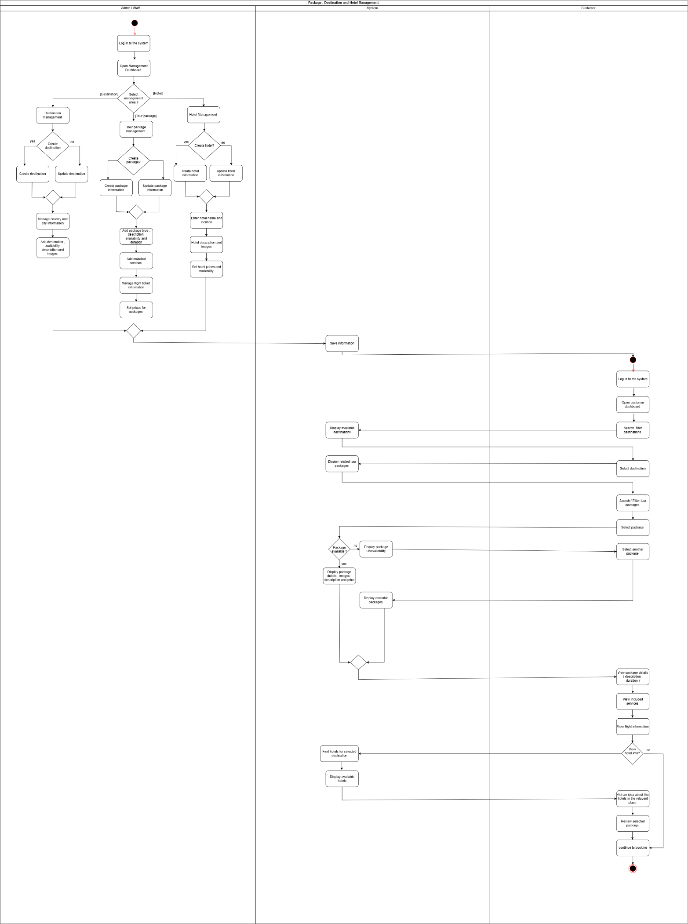
10. UML Activity Diagram
Figure 3: EP02 – Package, Destination & Hotel Management

11. Diagram Validation
Validation Question | Yes | No | Comments
Is the start of the process clear? | ✓ |  | Initial node + select area
Are all major actors represented as swim lanes? | ✓ |  | Admin/Staff, Customer, System
Is every activity in the correct swim lane? | ✓
Are activity labels clear and action-oriented? | ✓ |  | Create, Update, Search, View
Are decision outcomes shown with guard conditions? | ✓ |  | [Destination], [Create], [Yes]
Are alternative management areas represented? | ✓ |  | 3 branches
Is package availability represented? | ✓ |  | [Yes]/[No]
Are end points clearly shown? | ✓
Does the diagram represent the AS-IS process accurately? | ✓ |  | Manual catalogue maintenance

12. Analysis of the Current Process
No. | Problem Identified | Evidence | Business Impact
1 | Destination info becomes outdated | Manual maintenance of details, descriptions, images | Customers receive inaccurate information
2 | Package info requires repeated manual updates | Description, duration, pricing, availability maintained separately | Higher admin workload, inconsistent data
3 | Package availability not updated promptly | Depends on staff keeping records current | Customers see unavailable packages
4 | Hotel information requires manual maintenance | Name, location, images, prices updated by staff | Outdated hotel info → extra inquiries
5 | Information in disconnected/manual processes | Paper, spreadsheets, email, phone | Duplicate entry, inconsistencies, slower processing
6 | Limited customer self-service access | No centralized customer information platform | Customers depend on staff for basic info
7 | Pricing/availability can become inconsistent | Package and hotel info maintained separately | Customer dissatisfaction, operational errors

13. Measurable Baseline Indicators (KPIs)
KPI | How It Could Be Measured
Average time to create a destination listing | Time from starting data entry to completing the record
Average time to create/update a tour package | Time from starting package maintenance to saving completed package
Average time to update hotel information | Time required to update hotel details, images and pricing
Number of outdated package records | Count of packages whose pricing/availability not updated within review period
Number of outdated hotel records | Count of hotel records with outdated pricing or descriptions
Destination/package information error rate | Records requiring correction ÷ total records reviewed × 100
Average customer information-search time | Time a customer takes to find required destination or package info
Number of inquiries caused by missing information | Count of customer inquiries requesting info that should be available

14. Process Assessment
The current Package, Destination and Hotel Management process relies heavily on staff to create, update and maintain travel information. Destination descriptions and images, package details, pricing, availability, included services, flight information and hotel information must be maintained accurately. Use of manual procedures and disconnected spreadsheets increases the risk of duplicated data, outdated information and inconsistent pricing or availability.
Package and Destination Administrators and customers are the main affected parties. Administrators spend time maintaining multiple categories of information; customers may need to contact staff when information is incomplete or outdated. A centralized Travel GO platform will allow structured management functions for staff and reliable search/filter/view capabilities for customers. Baseline measurements should be collected for listing creation time, update frequency, error rates and information-related inquiries.

5.3 EP03 – Booking & Customer Journey
Responsible: Dissanayake S.D.D.H. (IT24104104)

5. Process Scope Definition
Item | Student Response
Process name | Tour Package Booking Process
Triggering Event | Customer decides to book a tour package after viewing catalogue information.
Start Point | Customer selects a package and initiates a booking request (currently via phone/email/walk-in).
End Point | Booking is confirmed, cancelled or completed; customer may leave a review.
Main Business Objective | Enable customers to reserve tour packages and allow staff to review, confirm and track bookings efficiently.
Items Within Scope | Package selection, travel date & traveler details, optional hotel, booking creation/modification/cancellation, status management, history, inquiries, reviews, notifications.
Items Outside Scope | Creating packages (EP02), payment processing (EP04), visa processing (EP04), user account management (EP01).

6. Swim lanes
Swimlane | Main Responsibilities
Customer | Select package, enter travel details, optionally add hotel, submit booking, view status, modify/cancel, submit inquiry/review.
Travel Consultant / Booking Officer | Receive booking requests, review details, confirm or reject, update status, handle inquiries.
System (future) | Record booking, maintain status history, send notifications (currently largely manual).

7. Process Activities
No. | Activity | Responsible
1 | Select tour package and initiate booking | Customer
2 | Enter travel date, number of travelers and details | Customer
3 | Optionally select hotel accommodation | Customer
4 | Submit booking request (status = Pending) | Customer
5 | Review booking details | Booking Officer
6 | Confirm, request more info, or cancel booking | Booking Officer
7 | Notify customer of status change | Booking Officer / System
8 | View booking status and history | Customer
9 | Modify or cancel eligible booking | Customer
10 | Submit review and rating after trip | Customer

8. Decision Points
Decision Question | Possible Outcomes
Does the customer want optional hotel? | [Yes] → select hotel; [No] → continue without hotel
Is the booking information complete and valid? | [Complete] → proceed; [Incomplete] → request more information
Does the officer confirm the booking? | [Confirm] → Confirmed; [Cancel] → Cancelled; [Request info] → return to customer
Is the booking still eligible for modification/cancellation? | [Yes] → allow change; [No] → reject change request

9. Handovers and Waiting Points
From | To | Information Transferred | Possible Issue
Customer | Booking Officer | Booking request + traveler details | Request lost or delayed (phone/email)
Booking Officer | Customer | Request for more information | Customer responds late
Booking Officer | Customer | Confirmation / cancellation notice | Notification delayed or missed

10. UML Activity Diagram
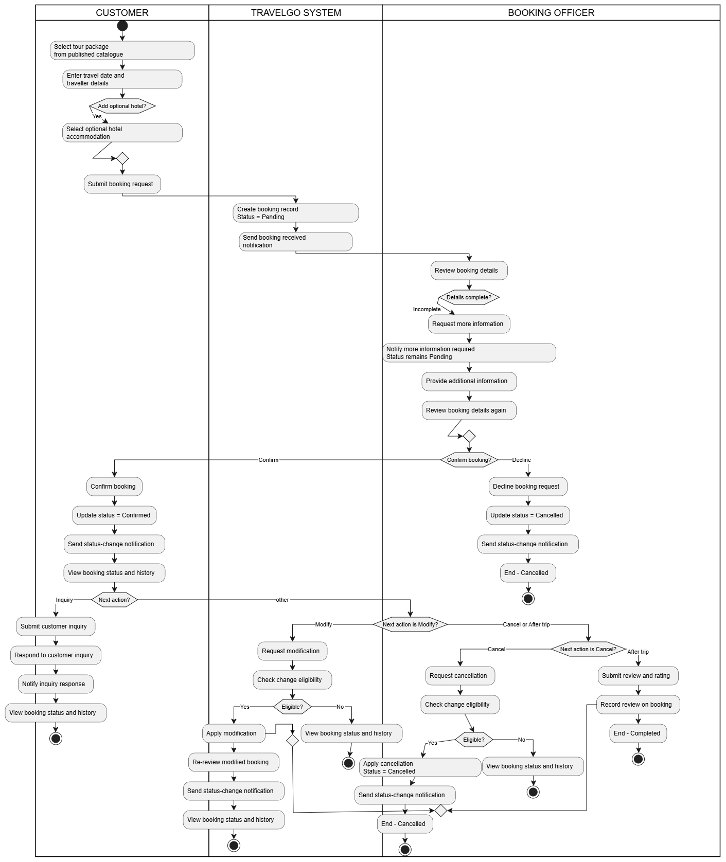
Figure 4: 3 EP03 – Booking & Customer Journey

11. Diagram Validation
Validation Question | Yes | No | Comments
Is the start of the process clear? | ✓ |  | Initial node present
Are all major actors represented as swim lanes? | ✓ |  | Customer, Booking Officer
Is every activity in the correct swim lane? | ✓
Are activity labels clear and action-oriented? | ✓ |  | Verb–object style
Are decision outcomes shown with guard conditions? | ✓ |  | [Confirm], [Cancel], [Yes]
Are rejection / cancellation paths represented? | ✓
Are rework loops represented? | ✓ |  | Request-info loop
Are end points clearly shown? | ✓ |  | Confirmed / Cancelled / Completed
Does the diagram represent the AS-IS process accurately? | ✓ |  | Manual multi-channel booking

12. Analysis of the Current Process
No. | Problem Identified | Evidence | Business Impact
1 | Bookings received through multiple channels | Phone, email, walk-in, messaging | Requests can be lost or delayed
2 | No single status view | Status tracked in spreadsheets or notes | Staff and customers lack real-time visibility
3 | Confirmation delays | Manual review and follow-up required | Customer uncertainty and possible cancellations
4 | Difficulty tracking booking history | Records scattered across channels | Hard to answer customer queries quickly
5 | Customers cannot self-serve status checks | Must call or email for updates | Increased workload for Booking Officers

13. Measurable Baseline Indicators (KPIs)
KPI | How It Could Be Measured
Average time from booking request to confirmation | Time between request receipt and status = Confirmed
% of bookings requiring rework / more information | Bookings returned for more info ÷ total bookings × 100
Average response time to customer inquiries | Time from inquiry receipt to first staff response
Number of status-related customer calls/emails | Count of contacts whose only purpose is status check
Booking cancellation rate before confirmation | Cancelled before confirmation ÷ total requests × 100

14. Process Assessment
The booking process is the core revenue activity of Travel GO. Currently, bookings arrive through multiple channels and are processed manually. There is no single authoritative status view, confirmation can be delayed, and customers must contact staff for updates. This creates extra work for Booking Officers and uncertainty for customers.
Automating request capture, status tracking and notifications will significantly reduce delays and improve customer experience. Priority should be given to a structured online booking form, real-time status dashboard, and automated confirmation notifications. Baseline measurements of confirmation time and status-related contacts will help measure improvement after the new system is introduced.

5.4 EP04 – Visa & Payment Management
Responsible: De Silva H.U.S.T. (IT24101683) – Project Manager

5. Process Scope Definition
Item | Student Response
Process name | Visa Application and Payment Processing Process
Triggering Event | Customer submits a visa application linked to a booking.
Start Point | Customer selects visa type and begins the application.
End Point | Visa is approved or rejected, and the final package payment is completed (if approved).
Main Business Objective | Manage visa applications with an upfront visa fee, process approval/rejection, and collect the final package payment after visa approval.
Items Within Scope | Visa type and required document - Customer visa application and document upload - Upfront visa fee payment request and payment - Staff review, approval or rejection - Documentation charge refund processing (upon rejection) - Customer status tracking - Final package payment after visa approval
Items Outside Scope | Embassy’s internal decision process - Live payment gateway - Creating bookings or packages

6. Swim lanes
Swimlane | Main Responsibilities
Applicant (Customer) | Select visa type, upload required documents, complete two-stage payments (Upfront Fee & Final Package Balance), and track application status.
Visa Processing System | Validate document completeness, send missing document alerts, generate payment requests & PDF receipts, auto-update application statuses, and trigger cancellation/refund workflows.
Visa Officer / Staff | Review document validity/authenticity, set upfront charges, and enter official embassy visa decisions (Approve/Reject).
Finance System | Verify/confirm upfront & final payments, retry failed transactions, and process documentation charge refunds upon visa rejection.

7. Process Activities
No. | Activity | Responsible
1 | Adds/updates Visa Types | Staff
2 | Submits visa application and uploads required documents | Customer
3 | Validates submitted documents and flags missing items | Visa Processing System
4 | Reviews documents and calculates upfront charges | Staff
5 | Pays upfront fee (Visa Fee + Documentation Charge) | Customer
6 | Verifies upfront payment and updates status to 'Visa Processing' | Finance System
7 | Enters embassy visa decision (Approve or Reject) | Staff
8 | Processes documentation charge refund & cancels booking (If Rejected) | Customer
9 | Pays the final package balance (If Approved) | Customer
10 | Confirms final payment, generates PDF receipt, and confirms booking | Visa Processing System

8. Decision Points
Decision Question | Possible Outcomes
Are all required documents submitted? | [Yes] → Proceed to staff document verification ; [No] → Send missing document alert to customer.
Is the upfront payment successful? | [Yes] → Lock charges, generate receipt, and start visa processing ; [No] → Trigger payment failure alert and offer retry option.
Is the visa application Approved or Rejected? | [Yes] → Set status to 'Visa Approved' & request final package payment ; [No] → Refund documentation charge only & cancel booking
Has the final package payment been completed after approval? | [Yes] → Generate final receipt PDF and set booking status to 'CONFIRMED’; [No] → Send payment failure alert & retain booking in pending state

9. Handovers and Waiting Points
From | To | Information Transferred | Possible Issue
Customer | Visa Officer | Visa application + uploaded documents | Incomplete documents or poor-quality scans
System | Customer | Missing document alerts / Upfront payment request | Technical delivery failure or customer delays response
Customer | Finance System | Upfront fee payment (Visa + Doc charge) | Payment gateway timeout, card decline, or customer delay
Finance System | System | Upfront payment status confirmation (Success/Failed) | Delay in API status sync between Finance and System
Visa Officer | System | Embassy visa decision (Approved / Rejected) | Delay in receiving embassy update or manual entry delay
System | Finance System | Refund request for documentation charge (If Rejected) | Refund processing delay in Finance System
Customer | Finance System | Final package balance payment (If Approved) | Payment failure or delay near the 3-day travel deadline
System | Customer | Final PDF receipt & Booking Confirmation notice | Email/PDF generation system failure

10. UML Activity Diagram

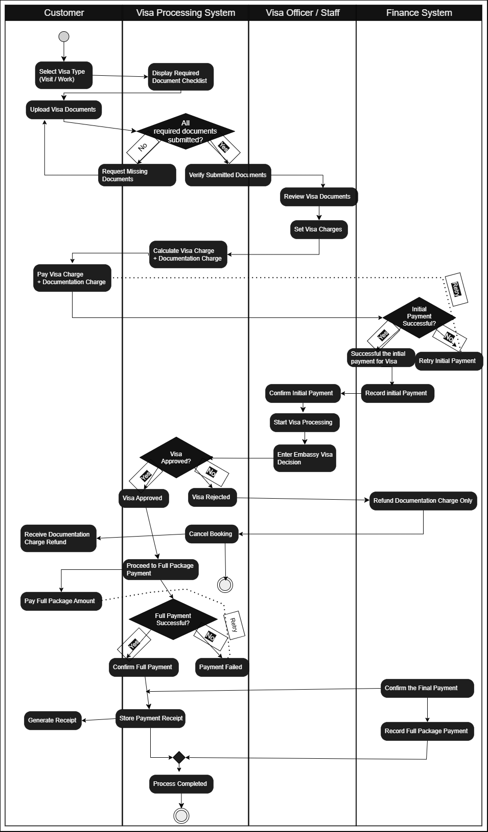
Figure 5: EP04 – Visa & Payment Management

11. Diagram Validation
Validation Question | Yes | No | Comments
Is the start of the process clear? | Yes |  | Initial node – visa type selection
Are all major actors represented as swim lanes? | Yes |  | Includes Customer, Visa Processing System, Visa Officer, and Finance System
Is every activity in the correct swim lane? | Yes |  | System automation, staff reviews, customer actions, and finance steps are properly mapped.
Are activity labels clear and action-oriented? | Yes |  | All activities use action verbs
Are decision outcomes shown with guard conditions? | Yes |  | [Yes]/[No], [Approved]/[Reject]
Are rejection paths represented? | Yes |  | Includes visa rejection path
Is the stock-availability decision represented? |  | No | physical stock is not applicable to visa processing
Is the USD 5,000 approval threshold represented? |  | No | Upfront Fee vs Final Package Balance
Is the insufficient-budget path represented? | Yes |  | Mapped as the "Payment Failed / Retry
Is the payment-retry / reminder loop represented? | Yes |  | Mapped as the "Missing / Invalid Document Alert & Re-upload
Are end points clearly shown? | Yes |  | Both successful booking confirmation and cancelled booking end states use final activity nodes.
Does the diagram represent the scenario accurately? | Yes |  | Manual verification process

12. Analysis of the Current Process
No. | Problem Identified | Evidence | Business Impact
1 | Document completeness checked manually | No automated checklist before officer review | Slower first review, repeated back-and-forth
2 | No prioritization of verification queue | Applications reviewed in order emails arrive | Urgent applications may be delayed unfairly
3 | Payment and visa status in separate spreadsheets | Finance and visa records not linked | Status update delays after payment
4 | No defined threshold for high-value fees | High-value cases handled informally | Inconsistent decision-making and delays
5 | Applicants have no self-service status view | Status inquiries handled by phone/email | Increased workload for Visa Officers

13. Measurable Baseline Indicators (KPIs)
KPI | How It Could Be Measured
Average visa application processing time | Time from submission to approval/rejection
% of applications returned for missing documents | Applications with missing-doc request ÷ total × 100
Average visa-fee payment confirmation time | Time between payment request and confirmed payment record
Visa approval-to-rejection ratio | Approved applications ÷ rejected applications (per period)
Average time to notify applicant of final decision | Time between officer decision and notification sent

14. Process Assessment
The current visa application process depends heavily on the Visa Officer manually checking document completeness and authenticity, with no automated checklist to catch missing items before the officer’s review begins. Every incomplete submission consumes a full review cycle before the applicant is told what is missing.
Major delays occur at document verification and at reconciling payment confirmation with application status, since these are tracked in separate spreadsheets. Applicants and Visa Officers are the most affected. Manually cross-referencing payment records against visa applications creates no direct business value and is a strong candidate for automation. Priority should be given to automated document-completeness checking and linking payment confirmation directly to application status. Before designing the To-Be process, evidence should be collected on typical document-rejection rates, average processing times by visa type, and the frequency of high-value fee cases.

Appendix A – Meeting Notes
Item | Details
Meeting purpose | Agree client organization (Travel GO), confirm four epics, allocate one epic to each member for individual process analysis.
Attendees | De Silva H.U.S.T., Bandara U.G.V.R., Dissanayake S.D.D.H., Abhimani N.H.A.
Key decisions | Travel GO confirmed as client; each member independently completes items 5–14 for their assigned epic; group jointly responsible for Executive Summary and Stakeholder Analysis (items 1–4).
Epic allocation | EP01 – Bandara; EP02 – Abhimani; EP03 – Dissanayake; EP04 – De Silva.
Follow-up actions | Each member drafts process scope, swim lanes, activities, decisions and handovers, then exchanges diagrams for peer validation.
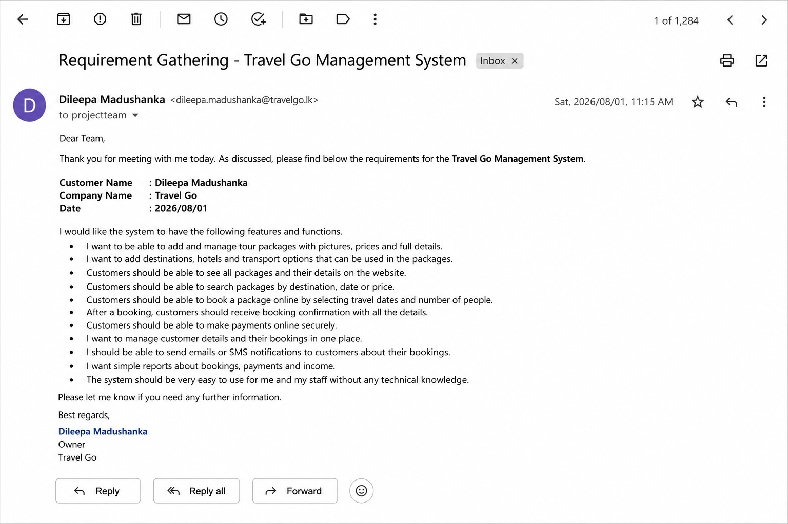
— End of Business Architecture Assessment Report —

